Multiple choice section

|  |  |  |  |  |  |  |  |
| --- | --- | --- | --- | --- | --- | --- | --- |
| Question | 1 | 2 | 3 | 4 | 5 | 6 | 7 |
| Answer | C | B | A | B | A | B | D |

Question 1 [9.5]

C

Two shapes are congruent if all corresponding angles and side lengths are equal.

Question 2 [9.1]

B

AAA. The third angle can be found from the other two angles.

Question 3 [9.1]

A



Question 4 [9.2]

B

We have no information about the size of .

Question 5 [9.3]

A

Alternate angles on parallel lines are equal. Then the triangles can be proven to be congruent by SAS.

Question 6 [9.4]

B

As the triangles are similar, the ratio of corresponding sides will be the same.



Question 7 [9.2]

D

The SAS test for congruency needs the corresponding angle to be included between the corresponding sides. All equilateral triangles are similar (AAA).

Question 8 [9.6] [10A]

D

 = 126°

 = 63°

Multiple-choice total marks: 8

Short answer section

Question 9 2 marks [9.2]

**(a)** To *bisect* a line is to divide its length into two equal lengths.

**(b)** If two shapes are identical in shape but different in size, they are said to be *similar*.

Question 10 2 marks [9.1]

Congruent shapes are identical in shape and size. Congruent shapes consist of straight sides where all corresponding sides and angles are the same size. For example:

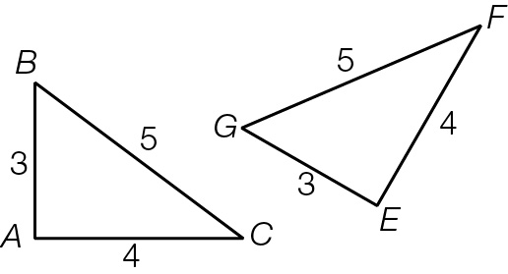

Question 11 4 marks [9.4]

**(a)** Side ratio =   
= 

**(b)** x=   
=9

Question 12 2 marks [9.2]

An equilateral triangle has all three sides the same length, so that once one side is given, all sides are known. Therefore, SSS applies, so the two triangles are congruent.

Question 13 5 marks [9.2]

(a)

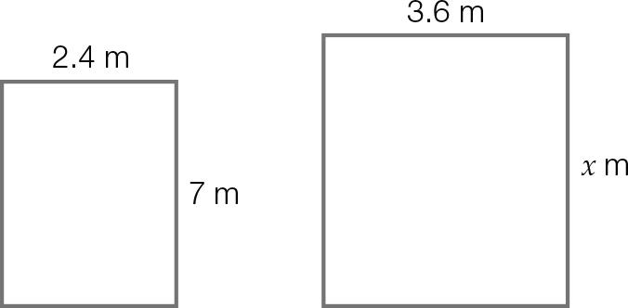

(b) Side ratio    


(c) Dilation factor =  =   
New width =  = 6 m

Question 14 3 marks [9.2]

**(a)**  (alternate angles on parallel lines) and *AC* is a shared side.  
This satisfies the condition SAS and SSS for congruent triangles.

(b) Yes, SAS and SSS can be used.

Question 15 2 marks [9.1]

Medium triangles e.g. ACH  
Small triangles e.g. ABI   
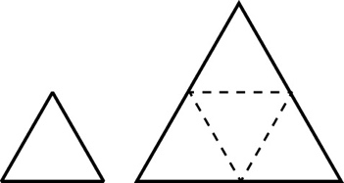

Question 16 3 marks [9.2]

**(a)** Any three of the following:  
****, ****, ****, ****, ****, ****, 

**(b)** *BCDJ*, *JDEF*, *HJFG*

**(c)** There are six pairs:  
∠*BIA* and ∠*DIJ*, ∠*BID* and ∠*AIJ*, ∠*IJD* and ∠*HJK*  
∠*IJH* and ∠*DJK*, ∠*JKE* and ∠*HKF*, ∠*JKH* and ∠*EKF*

Question 17 3 marks [9.3]

BD is a common side.

 (both 90°)

 (alternate angles on parallel lines)

 (RHS)

 (AAS)

Question 18 4 marks [9.2]

(a)   
  
x = 1.67 m

(b) Distance of the tree from the wall  
= 1.67 – 0.5  
= 1.17 m

Short answer total: 30

Extended answer section

Question 19 3 marks [9.3]

∠*BAE* = ∠*BCD* (base angles of isosceles triangle)

∠*AEB* = ∠*CDB* (given)

*AB* = *CB* (given)

 (AAS)

Question 20 6 marks [9.4]

**(a)** Corresponding angles on parallel lines are equal so the trianglesare similar using the AAA test.

**(b) **  
*x* = 15

**(c)**   
*y* = 16

Question 21 6 marks [9.4]

**(a)** For :  
*AF* = *EF* (given)  
*AC* = *EC* (given)  
*CF* is a common side.  
 (SSS)

**(b)**  (corresponding angles of congruent triangles)  
*CG* bisects ∠*ACE*.

**(c)** For  and :  
  
 (given)  
 (corresponding angles of congruent triangles)  
 (AAS)

Question 22 4 marks [9.6] [10A]

(a)    
(angle subtended by arc at centre = 2 × angle subtended by arc at circumference)

 (vertically opposite angles)

  
 (SSS)

(b)    
(angle subtended by arc at centre = 2 × angle subtended by arc at circumference)

 (straight angle)



Extended answer total: 19

TOTAL test results: 57